## horizontal line



INFOSYS320 Group 04

Requirement Specifications + Project Demonstration

*Members:*

* *Wannachai Burke (ID: 9620732)*
* *Vanessa Wong (ID: 6147601)*

URL to Unity Game hosted on Azure: <http://infosys320group4.azurewebsites.net/>

URL to Group 04 Github repository: <https://github.com/wbur788/UnityGameInfosys320>

TABLE OF CONTENTS

Requirements Specification

1 EXECUTIVE SUMMARY

**2 BACKGROUND, PROBLEM DESCRIPTION, SCOPE**

**3 USE CASE DIAGRAM**

**4 ERD**

**5 ASSUMPTIONS & DESIGN DECISIONS**

**6 NON-FUNCTIONAL REQUIREMENTS**

**7 CONSTRAINTS**

**8 UX CONSIDERATIONS AND DESIGN / TUFTE’S PRINCIPLES**

**9 PROJECT DEMONSTRATION**

Requirement Specification

# Executive Summary

Our proposed solution is an application that runs on hololens, to provide the user with an enriched, 3D learning experience. The solution consists of various functions which include the ability to view events happening, change settings to suit the user’s preferences, call for assistance, view a map and navigate through the museum. The main function, however, is the ability to view museum artifacts in a way that enhances the user’s experience as they travel through the museum. We focus on restraining our project so that it does not take away from the actual museum experience, and that is to admire that which is old and represents a part of who were are today. Therefore, we focus less on having amazing great animations and out-of-this-world games and more on providing a system that better helps us appreciate the past.

Our proposed solution offers features such as:

* Displaying information about museum artifacts as well as an option to narrate to the users about the artifact and email the information on the spot.
* Special exhibits such as those of fossils can present a 3D and to-scale model of the animal as if it were alive.
* Providing the user with an interactive map which is not a fully 3D model which can be rotated for easier view, but also the ability to direct you to the part of the museum you want to go.
* Providing users with the the museum programme and everything that is happening on the day of their visit as well as allowing them to set a reminder for the event and find it on the map.
* Allowing users to call for technical assistance anytime, anywhere during their Hololens experience within the museum. Help will be provided whether it be concerning how the Hololens works as well as technical errors/difficulties.

# Background

Technology, once a novelty, is becoming more prominently used in society today. Museums all over the world are starting to evolve; introducing things such as mobile apps, RFID and augmented reality - all with the goal of improving and revolutionizing the museum experience as a whole.

The purpose of this project is to propose an idea which will enhance the Auckland museum's user experience through the use of 3D technological innovation. By doing this not only will the users be able to learn and relive history but also go through an incredible experience which can only be found in the museum.

# Problem Description

With technology rapidly enveloping our human way of life, we tend to forget to appreciate the world before computers and smartphones and consequently take things for granted. A museum is a way for people of newer generations to delve into the world before their time, and to absorb the knowledge of how we came to be today.

However, a big problem with museums is that nowadays where smartphones and tablets are essential belongings, people tend to stare at their screens more than often, which takes away from the museum experience. Additionally, with easy access to the Internet around the clock, people would prefer to substitute a visit to the local museum with search engines such Google to educate them. This is a problem since, Google does not offer the environment and atmosphere that a museum does, that allows the user to be immersed and feel as if history has shaped our modern society.

# Scope

Our goal is to seek to improve the museum experience for all museum visitors from all ranges and reasons by integrating Hololens successfully to offer an immersive mixed reality experience. We can achieve this by procuring a few Hololens devices initially, and building an environment within the device which taps into the Auckland Museum database to provide information about artifacts and event scheduling, as well as supply 3D models of various museum artifacts. Also, we would also need to be able to install sensors that recognize user movements and determine whether users are in a position where they can see information/models through their Hololens device. While doing so we want to keep the experience close to tradition, and have special 3D-augmented features only when necessary.

Furthermore, since the Hololens device is an expensive device, and is currently considered as a luxury item and so we have taken into consideration that there should be a small rental fee for using the Hololens device. This way, the Auckland Museum can have a way to fund for even more devices as well as new features and technical updates. Also, since the amount of users that would want to use the device compared to the amount of devices available, the Auckland Museum may have to organize a booking system, that allows users to reserve use of the Hololens for a particular day. However, this is out of our scope and we will not be expanding on it.

# Use Case Diagram Overview

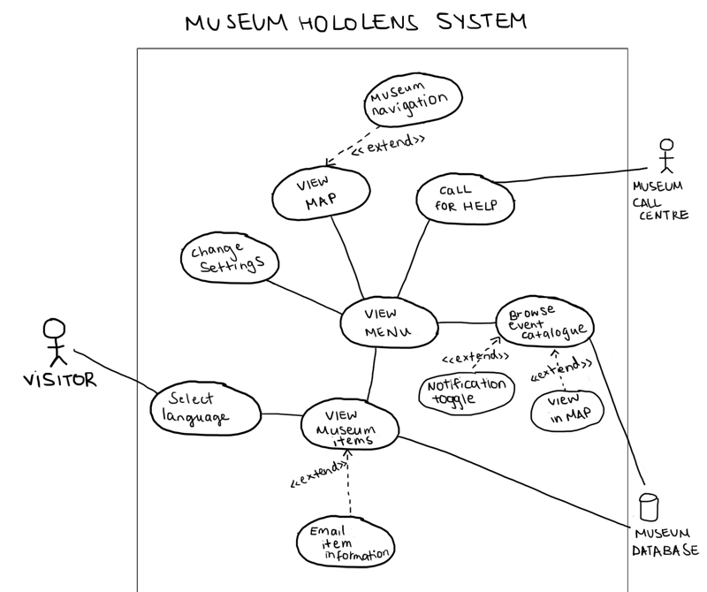

# Use Case Descriptions

When the user first uses the Hololens device they are presented with a Welcome screen that allows them to select a language. The screen is then cleared with minimal HUD display (Menu bar, date, time and location) while the user walks around the museum.

Upon hitting the menu button, the user is presented with 4 options, the event catalogue, settings, the map and an option to call for assistance. The event catalogue provides info on current events on today as well as providing an option to create a reminder as well as view in map. Settings allows for the user to change various Hololens interface options. The Map allows for users to navigate around the museum and Call for Help contacts the museum call centre in order to send out a technical staff member. Also viewing museum artifacts causes information to pop up as well as giving the option to email it.

# ERD

The information we need to capture is shown in the Entity-Relation Diagram above.

* The residency attribute in the Visitor Entity, is required in order to calculate admission costs into the Auckland Museum. If you are an Auckland resident, you can get free entry into the museum.
* The Hololens interface requires data from the user, that is what language should it be in, as well as data about museum events, staff available, exhibits and artifacts itself.
* Staff is needed because the Hololens, needs to know whether a staff member that has technical knowledge of Hololens is available to provide assistance.
* The Hololens Experience association entity keeps record of which user has possession of the Hololens device within the museum.
* The entity Exhibit is the different parts of the museums such as Maori Court that hold various different museum artifacts

# Assumptions and Design Decisions

## Assumptions

Due to the battery life of the Hololens device we are assuming that the time it takes for the average user to explore the entire museum and admire all its features will be less than around 3 hours. This way, users can experience the whole museum with Hololens and get it back to the desk for it to charge.

We also assume that users will generally prefer to share the Hololens between a group since it is easy to equip and remove, rather than use multiple Hololens devices.

## Design Decisions

In displaying the information about museum artifacts within Hololens, we came to decide that you would be able to see the information when you stood on a specific area instead of having the info surround the artifact continually. This way users can focus on the actual artifact itself and not be distracted by the fancy augmented features. This adheres to our goal of keeping the visual experience minimal and close to tradition.

We have also decided to implement a Call for Assistance button within our Hololens interface because since this technology is not yet mainstream and so the majority of our population will have no experience with it. Thus, we have decided that the Auckland Museum can provide immediate assistance to users anywhere in the museum who are having trouble.

We thought that some users may like the idea of having someone read the description of artifacts and exhibitions to them, so we thought it would be beneficial to have an option where they can get it narrated to them.

Ambient Sound is something we thought would improve the overall feel and atmosphere of the museum, to fully immerse ourselves in the environment. By ambient sound we mean just soft background noises that represent the area of the museum you’re in, so in the Maori Court it could be soft waiatas, whereas in the volcano area, it’s quiet but menacing rumbling of the earth.

Email is also a feature that allows users to preserve the information they learnt in the museum and send it back to either themselves or others.

# Non-functional Requirements

## Usability

The interface is simplistic and therefore easy to learn and remember. The icons are easily understood and recognized globally. This will give visitors of all different cultures a sense of familiarity in a place that may not be so familiar. The simplicity of the design does not overwhelm the user with excess functionality and information.

## Reliability

As the Hololens is running on a Windows 10 platform, it has more robust apps and more reliable functionality. The proposed solution therefore has a strong, supporting foundation upon which it runs.

## Performance

For performance, the Hololens should have minimal to no latency when displaying artifact information and loading 3D models. Information should either fade in smoothly or pop up as a whole, any lag will decrease UX.

## Supportability

Our proposed solution takes into consideration the alien experience Hololens may cause users who are trying it for the first time, and offers a Call for Assistance option within the Hololens itself. This option will also prove handy to those who are experience with Hololens but have encountered a technical error.

## Security

Since Hololens is an expensive device that is limited in availability, there must be security measures taken that prevent theft and damage. When users are assigned a Hololens device, they provide information about themselves, so that the museum can keep track of who is using the device. The device must also have a proximity sensor area that detects when it has been taken out of the museum and alerts authorities.

# Constraints

Due to the battery life of the Hololens device, users will only have a limited amount of time to use the Hololens. Also, since there will not be enough Hololens devices for everybody, some users will have to miss out.

# UX Considerations and Design / Tufte’s Principles

In considering the UX for the enhanced museum experience project, we wanted to home in on Tufte’s principle of ***‘Avoid distorting what data have to say***’. Meaning we wanted to keep the experience as true as we could without altering too much. While displaying fancy graphs of data, and 3D models of everything in the museum may be what people of the newer generation would appreciate, it does not capture the essence of a museum which is to reflect on the past. Thus, following another one of Tufte’s principle that is to ‘***Avoid 3D where it isn’t necessary’***.

In our design we have also put all our data and information onto some sort of backing screen, that provides the needed ***contrast*** for users to be able to clearly recognise and read text, without having to strain due to everything that is happening in the physical space.

We have also utilized the idea of ***layering and separating***, by providing different layers of information and popups, that are easily moved out the user’s view if necessary or can be closed if required.

Since the Hololens provides an a space where information isn’t limited to just a flat screen, but more to the entire space of the room, we practiced Tufte’s principle of ***presenting as much information as you can in small space***. That is, even though you have the whole room to put information in, we keep it in a small space so that we don’t distract users from the real experience of viewing museum artifacts.

# 

Project Demonstration

In the following pages we will be explaining how our proposed project works, and the different features that are included, in the interface as well as our prototype on Unity.

## Screens - A look into what the actual Hololens interface would look like

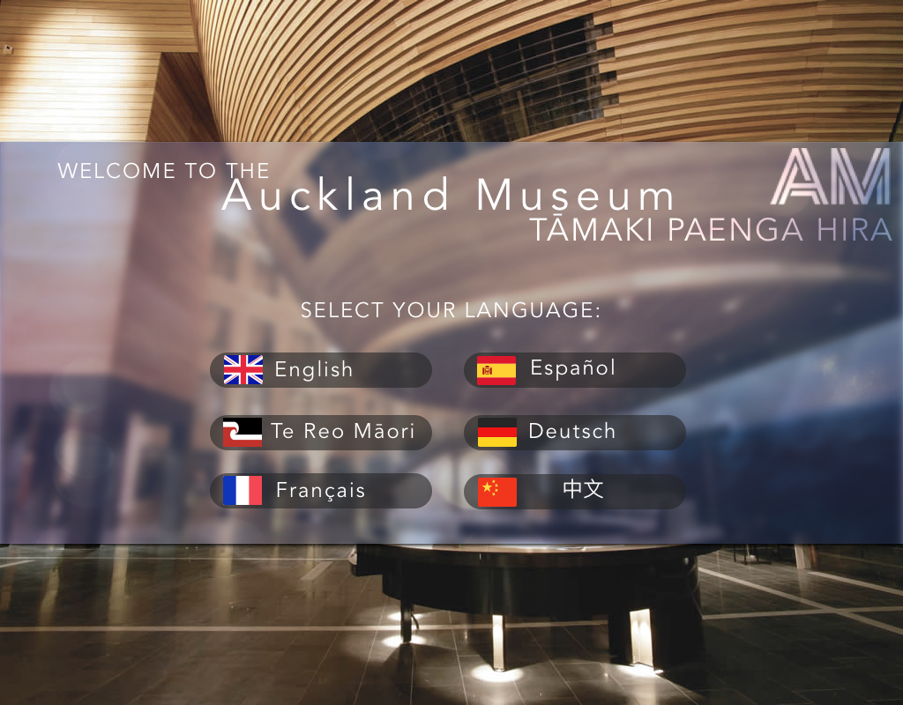

When you first equip the Hololens in the museum, you will be presented with a Welcome page and given a choice to provide a preferred language you want the system to be in.

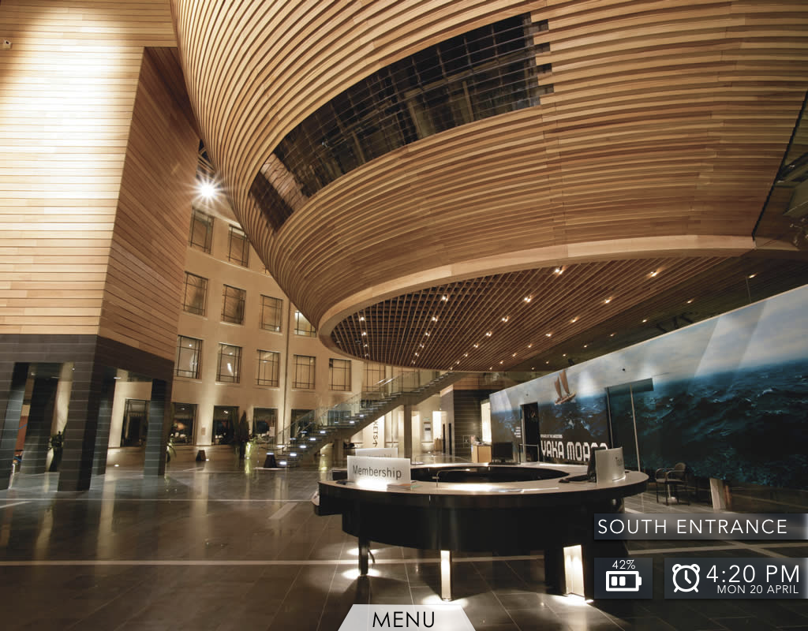

This is what the Hololens will look like normally, when transitioning between exhibits and floors of the museum. We kept it look real simply because ultimately, we want to enhance the museum experience and not change it completely by focusing on new fancy technology.

A menu button which is clickable is displayed as well as the time, date, current location and battery life of the Hololens.

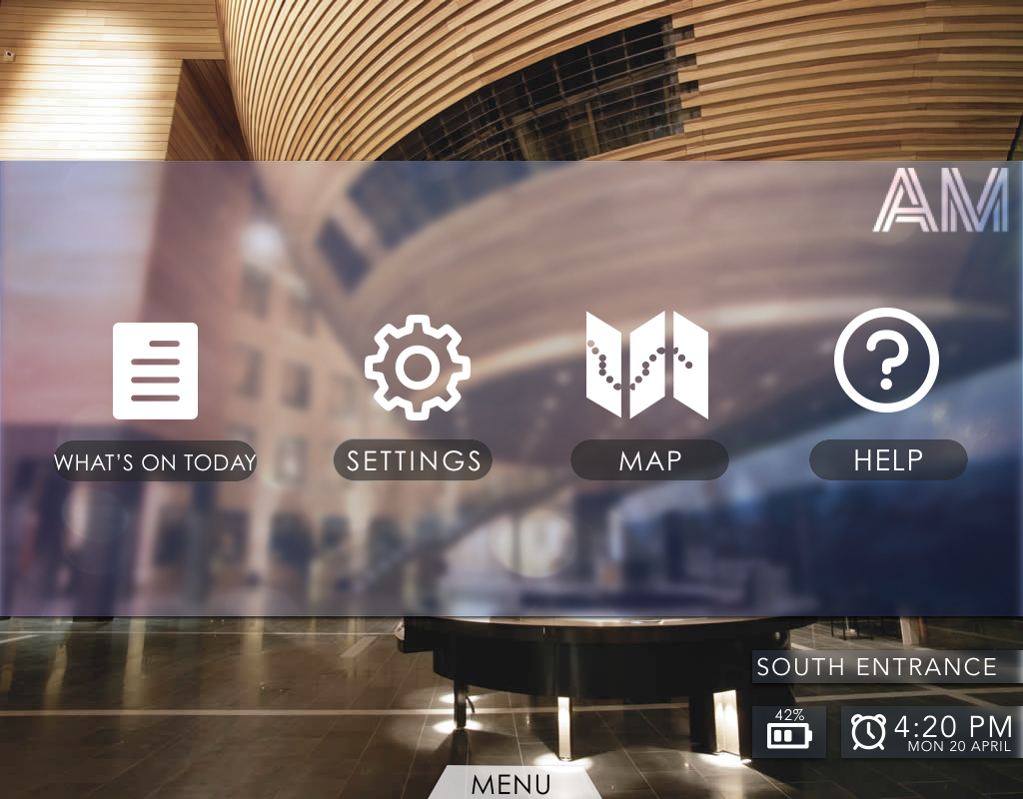

Upon clicking the menu button, you will be presented with four different options. What’s on Today, Settings, Map and Help.

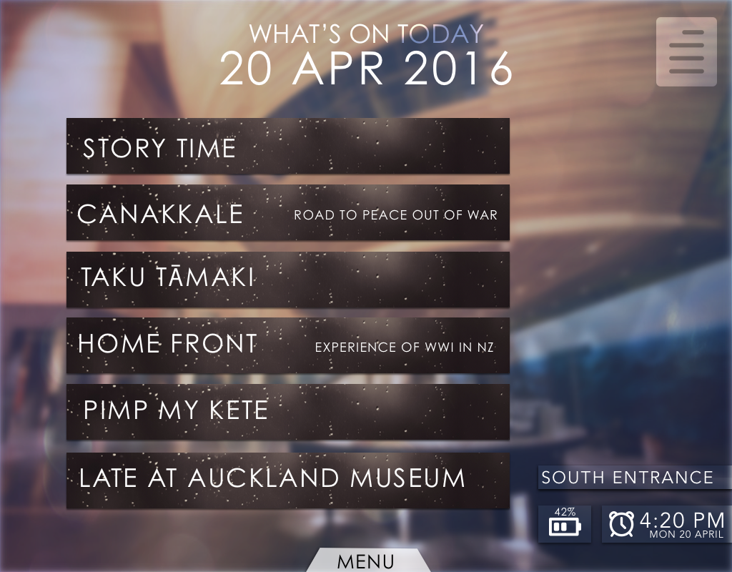

Clicking the What’s On Today button presents you with this accordion of events and performances that are on at the museum today, they are initially all collapsed and more events can be viewed by scrolling down.

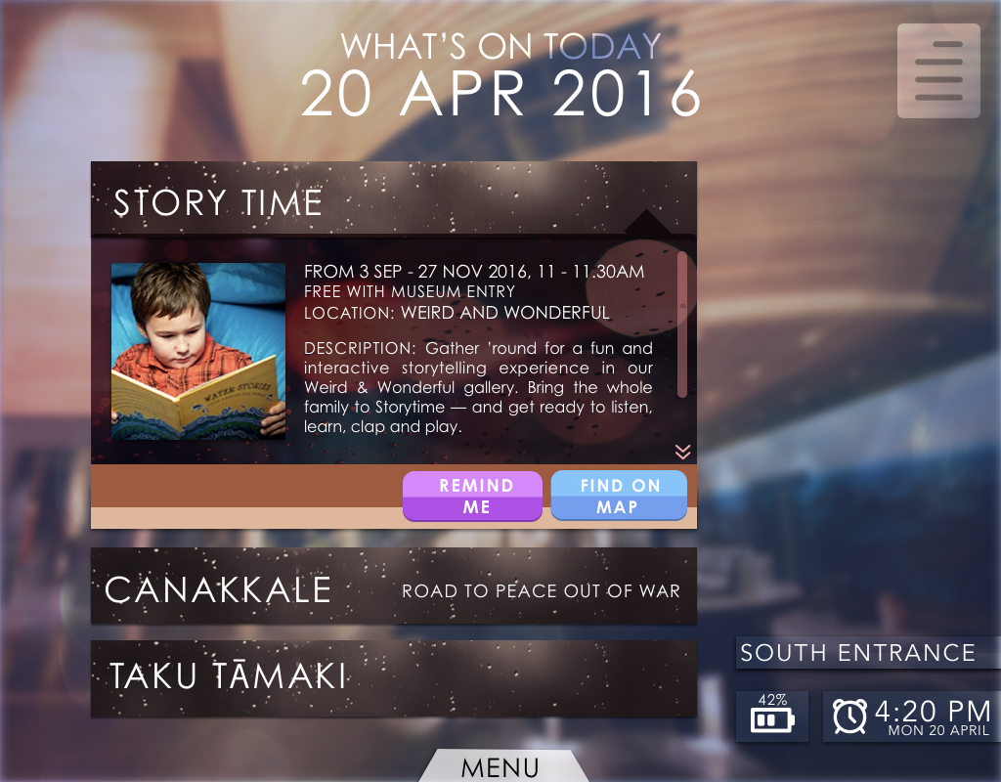

By tapping on an event, you expand the tab and the user is presented with descriptions of the event as well as the time is it available and where in the museum it is. The user is also provided with two options of setting a reminder, as well as finding where the specified room is in the museum.

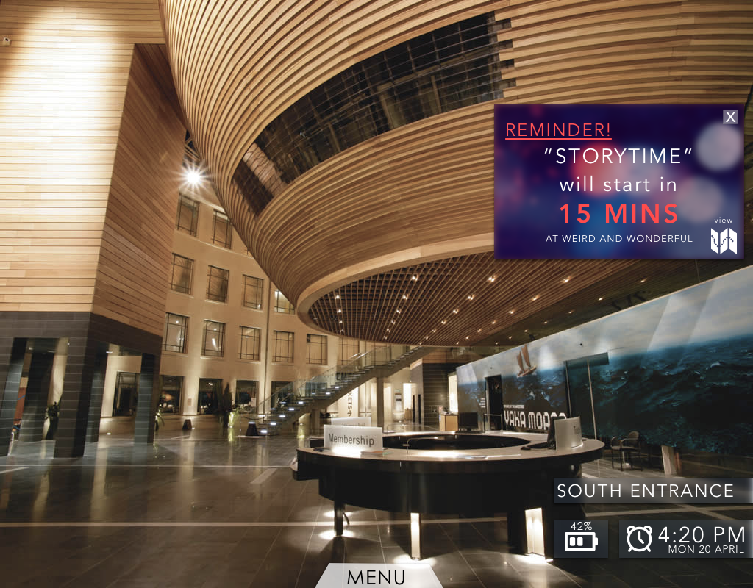

This is what the reminder/notification would look like as it pops up on your Hololens interface.

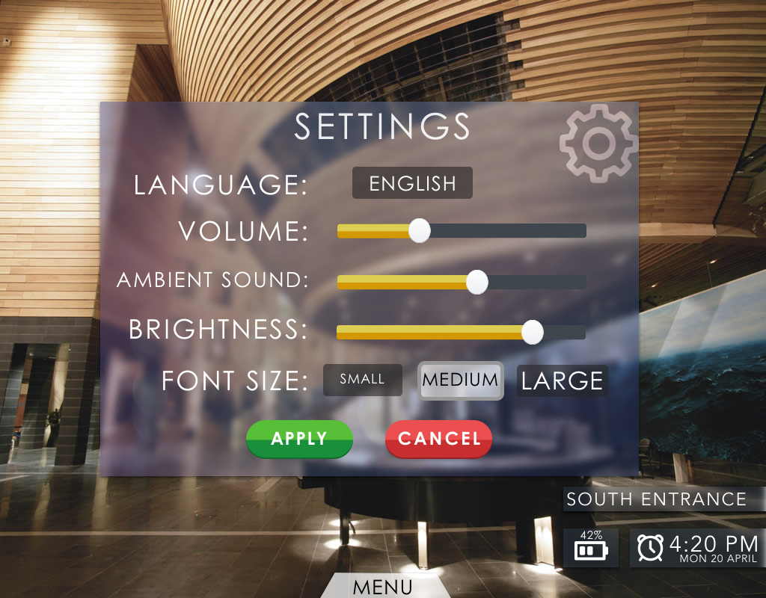

Clicking the Settings option on the menu will provide the user with the available presets that can be changed upon request. Volume, is how loud the narrator speaks when describing the museum artifact. Ambient sound, is how loud the background noise specific to the room will be. Brightness concerns the Hololens interface, such as the menu screens. Font Size accommodates for those who may have difficulty reading small text.

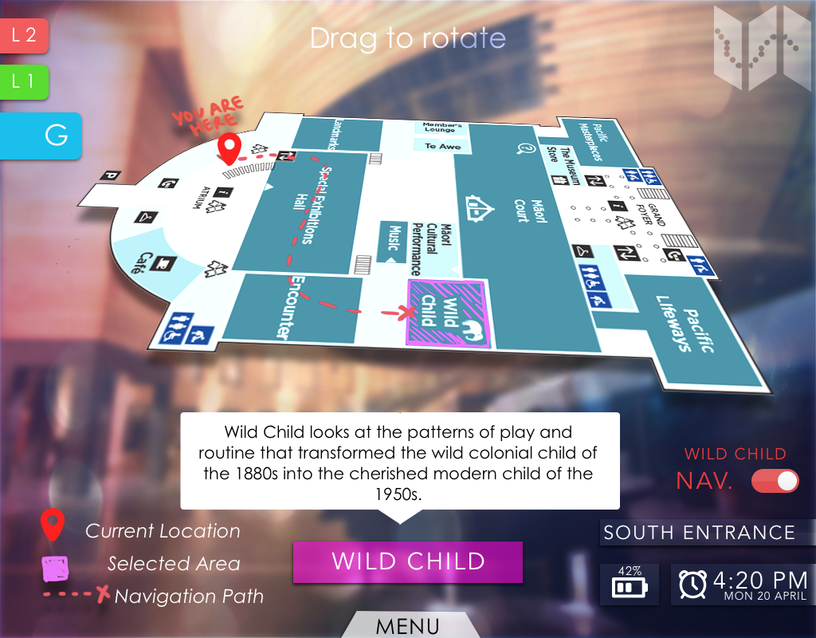

Clicking the ‘Map’ option, presents the user a 3D map that can be zoomed in and out and rotated to their liking. The map is interactive and allows users to select different exhibits between the different floors of the museum. Upon selection users are presented with a description of the exhibit as well as the option to navigate to the target area.

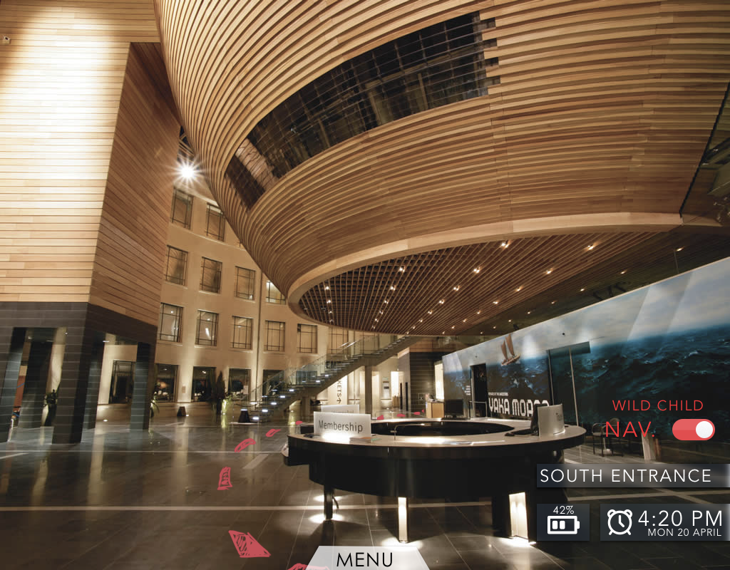

If the user chooses to navigate to the target area of the museum. Red trail lines will pop up on the interface that allows the user to follow them to the the target destination. Upon reaching the destination the red trail lines will disappear. This function can be turned off if the user changes their mind.

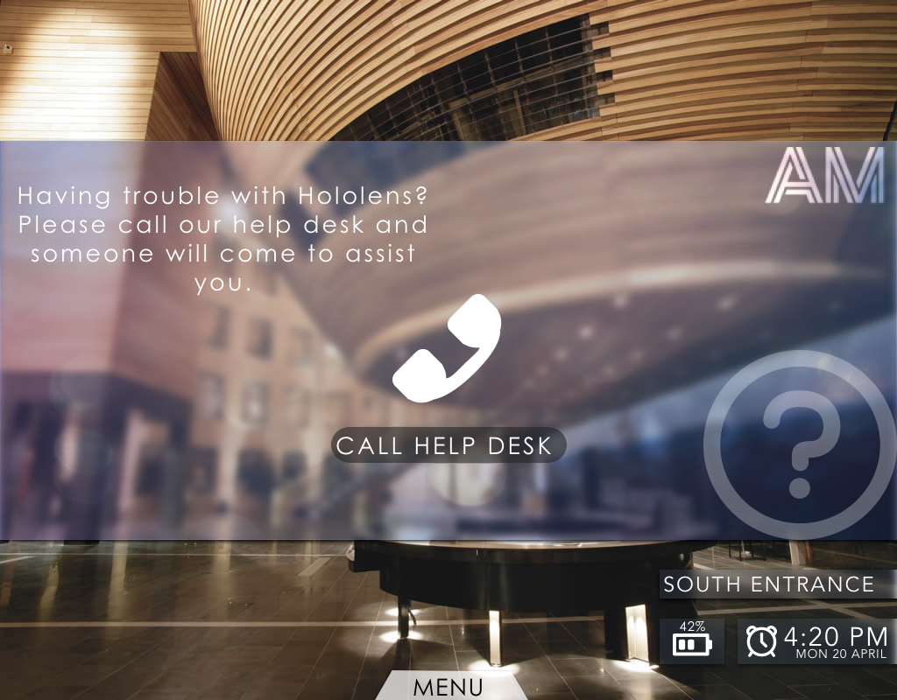

Clicking the Help button leads you to call the help desk, in which a technician can be sent to your position to assist with any problem concerning Hololens.

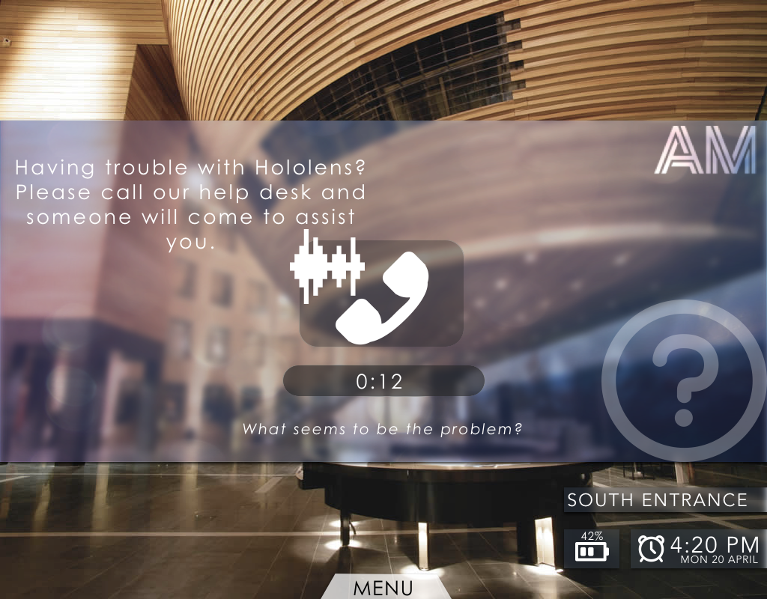

Further example of call in progress.

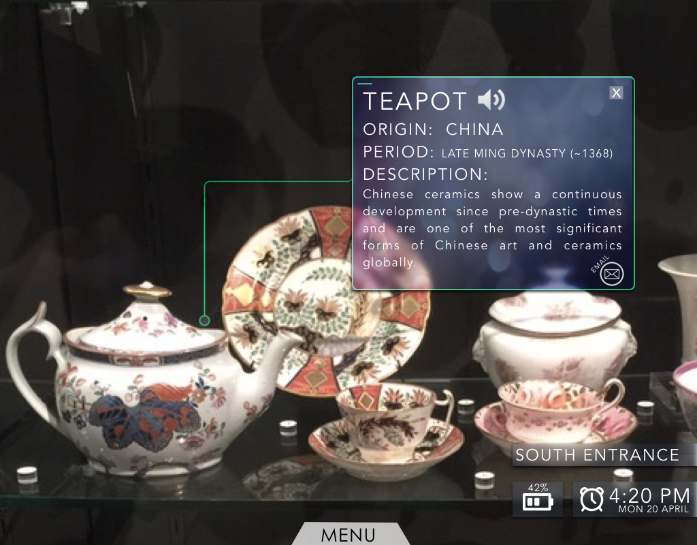

When standing in a certain spot in front of the artifact, information will pop up in a panel like above, that contains the information about artifact including the name, origin, period its from and a brief description. There are also options to narrate the details of the artifact represented by the speaker button, as well as an option to email the information.

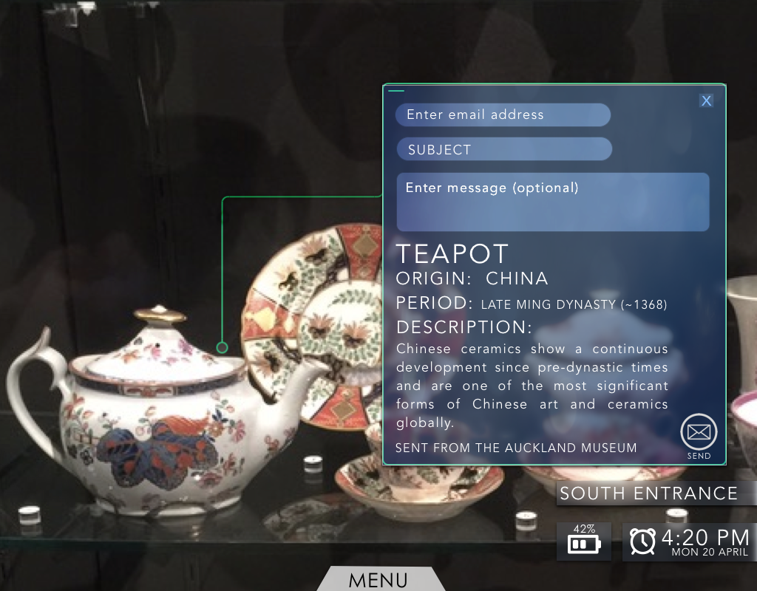

The user can choose to email information about particular artifacts to people. This may be particularly useful for research/school projects or if they are interested in certain parts of history. The user simply enters an email address to send the information to, a subject line and a message if needed.

Self-modelled museum model as done on Google Sketchup and then imported into Unity. 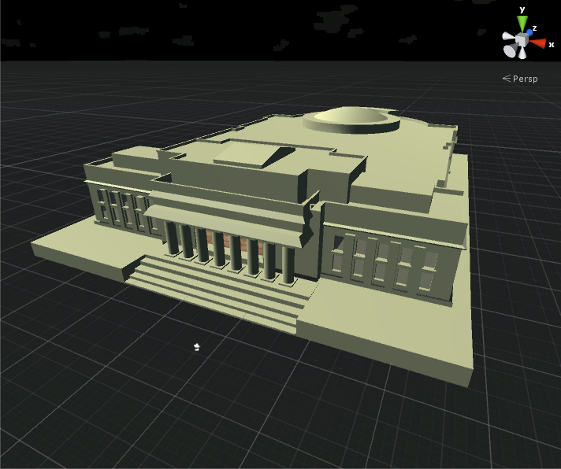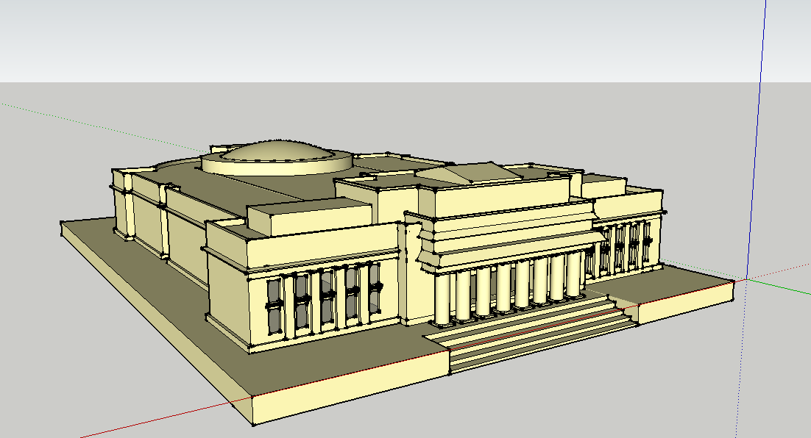

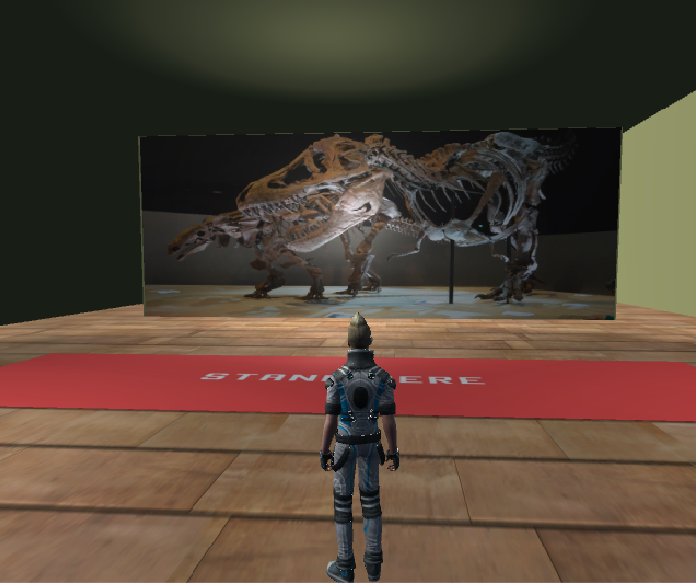In the prototype, planes were put on the walls of the model, and then photos to imitate actual exhibitions were placed on the plane. In this photo we see that the character is standing at a distance to show how the space looks like before the user stands on the specific spot.

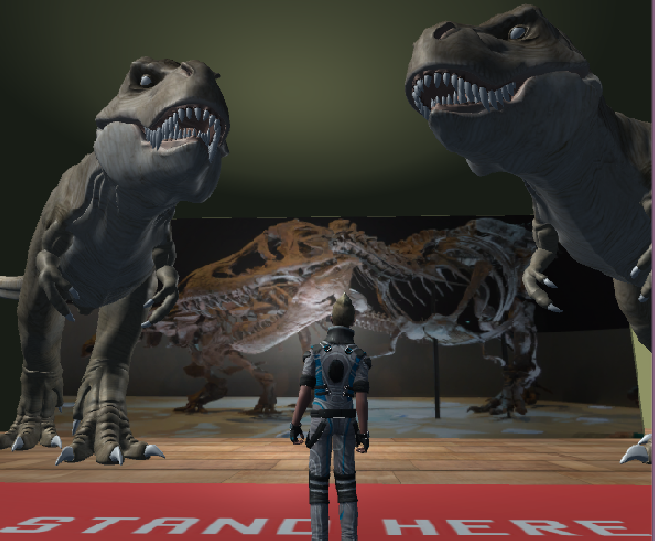

When the user stands on the right spot, then 3D models of the special dinosaur exhibit would appear, so the user would get to experience the dinosaur fossils in a completely surreal way, at least for the first iteration of the project the models will be stationary, but with further funding and development the models could become dynamic and have animations.

This is done by attaching a code to the floor panel object that makes the T-Rex models visible when stood on and then invisible upon leaving the panel.

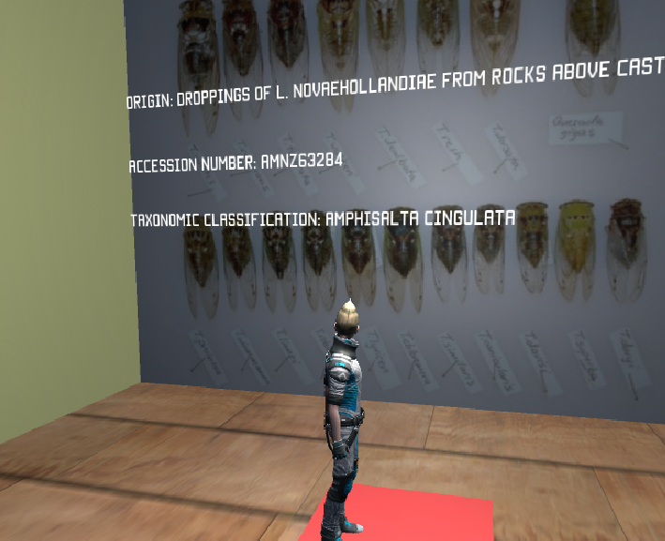

When standing on a designated interactive area while wearing the Hololens, information appears by the artifacts to give the user further insight into these items.

This part of the prototype is to emulate how the Hololens would obtain information. Hololens digs into the Auckland Museum database and retrieves the relevant information depending on the object and displays it to the user.

In the prototype, this is achieved by creating an EasyTable on the Swagger UI with a csv containing Museum data, which Unity retrieves via GET requests and deserialising the JSON into an object array. 3D text attached to invisible game objects is then dynamically updated based on relevant information and made visible when stood on the panel.

**NOTE: THIS WORKS CORRECTLY THROUGH THE UNITY APP. HOWEVER, ONCE BUILT AND PUT ON THE WEB AS A WEBGL GAME, THERE IS AN ERROR WITH READING DATA FROM THE EASYTABLE.**